DEDICATION

This work is dedicated to the Dibango’s Family for their love, support, encouragement and their unconditional sacrifices towards my academic success.

ACKNOWLEDGEMENTS

As a prelude to this internship report, we would like to express our sincere gratitude to all individuals and entities whose guidance, support, and encouragement have contributed to the successful completion of this work and to a productive academic year.We are particularly grateful to:

* **The Almighty LORD**, whose grace made everything possible. Without Him, none of this would have been achievable. All glory be to Him alone.
* **Mr. Armand Claude Abanda**, the Resident Representative of the African Institute of Computer Sciences, for his wise and invaluable instructive advice.
* **Mr. N**, the Chief Executive Officer of REALIZE, and his staff for their trust, warm welcome, encouragement, availability, and moral support throughout our internship period.
* **Mr. Derick Assane**, our academic supervisor and lecturer at AICS Cameroon, for his constant guidance, advice, and moral support during our academic and internship journey, which contributed to the realization of this project.
* **Mr. Tanue Monette**, our professional supervisor at REALIZE, for his help, advice, and encouragement that greatly supported the successful development of this project.
* The **Administrative and Teaching Staff of AICS Cameroon**, for their dedication, teaching, and guidance throughout the 2023-2025 academic year.
* Our **families and parents**, for their spiritual, moral, and financial support, which was instrumental in enabling us to complete this work.
* Lastly, all other individuals and organizations who contributed in one way or another to the realization of this project

CONTENT

TABLE OF FIGURES

LIST OF TABLES

LIST OF ABBREVIATIONS

ABSTRACT

RESUME

GENERAL INTRODUCTION

In today’s fast-paced world, technological advancements are transforming various sectors, including waste management. Digital innovations are helping cities and enterprises improve efficiency, reduce costs, and address environmental challenges. As a developing country, Cameroon is increasingly embracing the digital economy to boost growth and sustainability.

To contribute to this progress, students at AICS Cameroon are required to undertake a three-month internship to apply their academic knowledge in real-world scenarios. During our internship at **REALIZE**, an IT solutions company, we were assigned the theme: **“Conception and Implementation of a Waste Collection System.”**

Our project aims to design and develop a digital platform that optimizes waste collection processes, enhances efficiency, and promotes better environmental management. To achieve this, we conducted comprehensive research and structured our work into eight parts:

1. **Insertion Document:** Introducing the company and our internship experience, along with the project theme.
2. **Existing System:** Analyzing current waste collection methods.
3. **Specification Book:** Defining user needs, considering costs and deadlines.
4. **Analysis Document:** Presenting analysis methods and diagrams for understanding the system.
5. **Conception Phase:** Designing the overall and detailed architecture of the waste collection system.
6. **Realization Phase:** Demonstrating how the system will be built and implemented.
7. **Functionality Testing:** Showcasing the modules and how they operate.
8. **User Guide:** Providing instructions for users to operate the system effectively.

PART 1

INSERTION PHASE

Preamble

This report summarizes the company, the project we worked on, the tasks we completed, the tools used, and the results achieved during the internship.

Content Overview

INTRODUCTION

1. WELCOME AND INTEGRATION
2. GENERAL PRESENTATION OF REALIZE
3. ORGANISATION OF REALIZE
4. HARDWARE AND SOFTWARE RESOURCES
5. BRIEF PRESENTATION OF THE PROJECT

CONCLUSION

INTRODUCTION

Insertion is the way in which man can integrate a community, a group. Within the

framework of the academic internship, the insertion phase is a period in which the different

interns got to know more about their host company. Additionally, we got to know about the staffs, the different hardware and software used, the different department which constitute the company and we were introduced to our workspace, how the company functions both internally(that’s how the different task is schedule, the rules and regulations, working periods and so on). We also had a time to discuss amongst us interns on topics like what we love doing most, what we dislike, our believes, our best meals, sports, songs, our temperaments, our inborn talents and those we learn as we grow up. We shared about different realizations and failures in life.

1. WELCOME AND INTEGRATION

We arrived at REALIZE on Thursday, July 3, 2025, at 08:00. Greeting us were **Mr. TANUE Monette**, the Software Designer, and **Mr. Mengot**, the Senior Developer, who delivered an inspiring welcome and introduced the company’s operations and scheduling for our internship period. The initial meeting covered the challenges from the coding test required for the internship, REALIZE’s organizational structure and internal policies, and the allocation of workstations to each intern.

First-week activities: We set up at our designated workstations and received our initial task. A foundational verification of concepts using HTML and CSS ensured all interns started on an even footing. We brainstormed project ideas, with an emphasis on individual initiative; prior experience helped me contribute and refine these ideas. We conducted research on the proposed ideas, as REALIZE encouraged initiative and did not prescribe themes.

Second-week activities: JavaScript concept verification exercises were used to assess understanding and reasoning. A detailed discussion with the supervisor reviewed the specification book and its components, clarifying expectations for each section. Project ideas were further developed into concrete plans, leveraging familiarity with REALIZE’s expectations and processes.

1. GENERAL PRESENTATION OF REALIZE

### A. History

Realize is a Cameroon-based NGO and tech start-up founded by **Mr. NDELOGAKEH Daniel** in 2022. It offers IT solutions and promotes the use of new technologies in Cameroon.

### B. What is REALIZE all about?

#### i. Missions

Realize’s mission is to empower and sustain the use of technology through:

* Designing mobile software for businesses and individuals
* Supporting startups for rapid growth using IT
* Providing training and certifications to build qualified human resources
* Contributing to global sustainable development with innovative solutions and virtual reality

#### ii. Vision

Realize believes that unlocking the potential of organizations and individuals is possible through analysis, development, realization, and data analytics. Their vision is to shape a future of limitless innovation in the digital world.

#### iii. Activities

Realize’s activities include:

* Designing and hosting websites
* Software development and maintenance
* Providing training in software fields
* Creating multimedia content
* Offering IT consulting, support, and innovation.

##### C. GEOGRAPHICAL LOCATION

REALIZE is located at Yaoundé-Valler Amadou

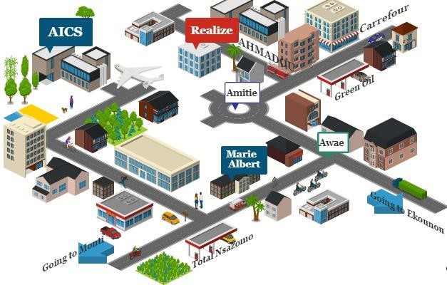*Figure 1: Realize location*

1. ORGANISATION OF REALIZE

### A. Administrative Organization

**Realize’s administrative structure is divided into several departments:**

#### 1. General Management

* Oversees the entire company
* Ensures departments function properly
* Sets project strategies
* Provides leadership and guidance
* Makes critical decisions impacting operations and reputation
* Acts as a point of contact for stakeholders like investors

#### 2. Human Resources

* Handles recruitment and hiring
* Acts as a link between employees and management
* Manages salaries, benefits, and employee policies
* Maintains employee records and HR systems

#### 3. Communication Department

* Manages public relations and company image
* Handles messaging to external stakeholders (customers, partners)
* Ensures effective internal communication
* Creates and manages content for various platforms

#### 4. Financial Affairs

* Develops and manages budgets and financial plans
* Prepares financial reports for management and authorities
* Controls costs and expenses
* Ensures tax compliance

#### 5. Technical Department

* Manages infrastructure like networks and hardware
* Handles data management and cybersecurity
* Maintains relationships with vendors and service providers

#### 6. Software Engineering Department

* Develops and supports software applications
* Maintains software throughout its lifecycle
* Executes and evaluates project realization

##### B. FUNCTIONAL ORGANISATION OF REALIZE

The functional branch of realize is organized as follows,

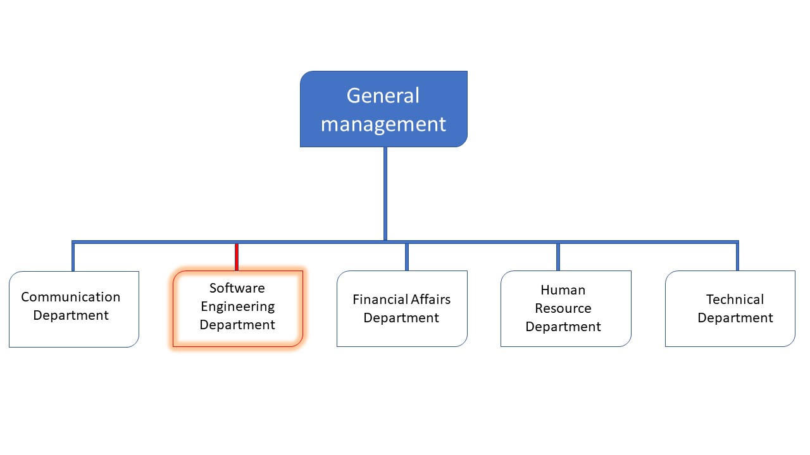

*Figure*

*2*

*:*

*Company functional organization*

*(*

*source: Realize*

*)*

1. HARDWARE AND SOFTWARE RESOURCES OF REALIZE
2. **HARDWARE RESOURCES**

*Table 1: Hardware resources (Source from REALIZE)*

|  |  |  |  |  |
| --- | --- | --- | --- | --- |
| **No** | **DESIGNATION** | **QUANTITY** | **CHARACTERISTICS** | **OBSERVATION** |
| 1 | MacBook Pro | 1 | APPLE | Good |
| 2 | Modem | 1 | CAMTEL | Good |
| 3 | LCD Screen | 1 | HP | Excellent |
| 4 | Training  equipment and  office furniture | / | / | / |

1. **SOFTWARE RESOURCES**

*Table 2: Software resources (Source REALIZE)*

|  |  |  |
| --- | --- | --- |
| **DESIGNATION** | **SOFTWARE** | |
| **Operation system** | | Windows 10, Mac OS, parrot Linux |
| **Design tools** | | Photoshop |
| **Integrated development environment**  **(IDE)** | | Visual studio code, |
| **Text editor** | | Sublime text, notepad++ |
| **Database management system (DBMS)** | | MongoDB, PostgreSQL, MySQL |
| **Web browser** | | Google chrome, Microsoft edge |
| **Document editor** | | Microsoft office word |
| **Presentation** | | Microsoft office PowerPoint |

1. BRIEF PRESENTATION OF THE PROJECT

During our insertion phase at REALIZE, we identified themes addressing specific problems and introducing innovation. After reviewing our initial ideas, our professional supervisor took the time to evaluate our themes and proposed some improvements. Finally, we had to go for the selected theme: **"CONCEPTION AND REALIZATION OF A WASTE COLLECTION SYSTEM."**

This platform aims to improve waste collection processes, making them more efficient and organized. It will help waste collectors and community members by providing a digital solution to manage their waste collection activities. Each contributor (community member or household) will have the ability to view their assigned collector, see the history of waste collected, and make online requests for waste pick-up. Collectors will be able to register waste contributions through the application and issue receipts to contributors for each collection. Additionally, the admin will have the capability to assign collectors to specific contributors, thereby streamlining the entire waste management process and reducing environmental nuisances caused by uncollected waste.

CONCLUSION

The insertion phase at REALIZE established the foundation for our internship, enabling rapid integration into the Software Engineering host unit and a clear understanding of the organization’s structure, workflows, and resources. We completed initial HTML/CSS exercises to validate core concepts and began shaping project ideas, preparing us to transition from onboarding to hands-on work. The phase culminated in the shift toward conceiving and implementing a waste collection system, setting the stage for practical design, stakeholder engagement, and scalable, impact-driven development.

PART 2

TECHNICAL PHASE

# FILE 1: EXISTING SYSTEM

Preamble

This section explains the existing system we’re studying and outlines the app we will build. It describes how the existing system works, where it falls short, and the problems this causes. It then presents practical fixes and the initial steps to implement them.

Content Overview

INTRODUCTION

1. THEME PRESENTATION
2. DESCRIPTION OF THE EXISTING SYSTEM
3. LIMITATIONS OF THE EXISTING SYSTEM
4. PROBLEMATIC
5. PROPOSED SOLUTION

CONCLUSION

INTRODUCTION

In this part of our report, we will explain our theme. We will also study the current system and identify its strengths and weaknesses. Based on this analysis, we will present the problem statement, which is the main challenge or gap that the current system faces. Finally, we will propose a solution that addresses this problem and improves the system.

* 1. THEME PRESENTATION

Our theme, **“Conception and Implementation of a Waste collection System”**, our project focuses on designing and developing a digital waste collection system to improve how waste is collected, tracked, and managed in urban and hard-to-reach areas.

The system connects households, businesses, and waste collectors through an intuitive interface, addressing critical inefficiencies in traditional waste management (like **HYSACAM’s** limitations in Cameroon).

The conception phase involves analyzing existing waste management practices (by **AMAH Association and HYSACAM**), identifying limitations such as inefficiency, poor payment tracking, and inaccessible neighborhoods, and proposing a digital solution.

The implementation phase consists of creating a mobile application that allows residents to register, subscribe, and make payments online, integrates **GPS tracking** for precise pickups, coordinates agents’ routes, and provides management with real-time monitoring and reporting tools.

Overall, this project aims to optimize waste collection, increase operational efficiency, and ensure better service coverage, particularly in areas that are difficult to reach, while making the system more transparent and convenient for both residents and waste management agents.

* 1. DESCRIPTION OF THE EXISTING SYSTEM

In Cameroon, waste management is mainly handled by companies such as **HYSACAM** (Hygiène et Salubrité au Cameroun) and smaller organizations like the **AMAH Association**. Both are responsible for maintaining hygiene and sanitation in various communities.

**HYSACAM** focuses largely on servicing accessible urban and suburban areas. Their teams consist of drivers, cleaners, and inspectors who clean trash bins, collect waste, and ensure equipment is in working order. While their operations cover large zones, they face challenges in reaching certain hard-to-access neighborhoods, especially those located on steep terrain, near cliffs, or in narrow, unpaved streets. Trucks may be unable to navigate these areas, leaving residents with irregular waste collection services.

In contrast, **AMAH Association** operates on a smaller scale but takes a more personalized approach, especially in less accessible areas. AMAH agents often go door-to-door, directly informing residents of their presence and collecting garbage even in neighborhoods that trucks cannot reach. They cover households, restaurants, and community spaces; ensuring waste is collected from places that larger trucks overlook.

However, both systems face operational challenges:

* No real-time tracking of bins or households: Teams do not know exactly when waste bins are full, leading to unnecessary trips or delayed collections.
* Limited communication with residents: Many residents wait for trucks without knowing the exact collection time, and some miss the opportunity to dispose of their waste.
* Accessibility issues: HYSACAM struggles with hard-to-reach locations; while AMAH’s manual, approach is labor-intensive and time-consuming.
* Inefficient resource usage: Wasted fuel, increased travel time, and higher operational costs.

These challenges result in uncollected waste in some areas, increased health risks, and higher operational expenses. Your proposed system aims to support AMA Association by integrating a GPS-based tracking solution that can monitor households, restaurants, and communities, enabling optimized route planning and timely pickups. This would ensure residents no longer have to wait unnecessarily for trucks and that waste collection teams operate more efficiently.

* 1. LIMITATIONS OF THE EXISTING SYSTEM

Table 3: Limitations, Consequences and proposed solutions

|  |  |  |
| --- | --- | --- |
| Limitations | Consequences | Proposed Solutions |
| No central digital system for households to request waste collection | Residents must wait for fixed schedules, often missing pickups | Mobile app where residents can log in, subscribe, and request collection directly |
| Lack of real-time location sharing between clients and collectors | Collectors waste time searching or driving to wrong addresses | GPS integration that automatically shares client location after subscription or pickup request |
| Inconvenient and manual payment methods | Delays in payment, need for cash handling | Integrated payment API supporting Orange Money and Mobile Money for instant, cashless transactions |
| No option for urgent pickup requests | Waste can pile up in special situations (meetings, events, etc.) | “Request Immediate Pickup” feature allowing clients to notify collectors outside normal schedules |
| No tracking of subscription and collection history | No transparency for clients or operators, disputes may arise | User dashboard to view payment history, collection records, and subscription status |
| No efficient communication channel between clients and collectors | Misunderstandings and delays in service | In-app messaging or push notifications for updates and confirmations |

* 1. PROBLEMATIC

In Cameroon, urban waste management faces significant challenges. While companies like HYSACAM provide general waste collection, they are often unable to reach hard-to-access neighborhoods, leaving some households without consistent service. Associations like AMAH attempt to fill this gap with door-to-door collection, but their operations remain manual, time-consuming, and inefficient, relying on paper-based records and physical visits.

The lack of digital tools for tracking households, managing subscriptions, processing payments, and scheduling pickups creates several issues:

1. Inefficient waste collection, especially in areas with difficult terrain.

2. Delayed or missed services, leading to unhygienic conditions.

3. Difficulty in monitoring payments and subscriptions, increasing the risk of revenue loss.

4. Limited communication between residents and collection agents, causing frustration and reduced satisfaction.

Therefore, there is a need for a digital system that integrates real-time household tracking, payment processing, and pickup scheduling, to improve efficiency, transparency, and accessibility in waste management, particularly for underserved neighborhoods.

* 1. PROPOSED SOLUTION

The proposed solution is a mobile-based waste collection system that allows residents to subscribe and pay online, tracks households via GPS for efficient pickups, and provides digital management tools to coordinate services and improve coverage, efficiency and transparency in to our homes and country.

1. Mobile Application for Residents

Develop a user-friendly app allowing residents to register, subscribe, and make payments directly through mobile money, Enable residents to schedule pickups or request services.

2. Real-Time Location Tracking

Use GPS APIs to track households’ locations, especially in hard-to-reach or inaccessible areas, allowing collection agents to locate homes efficiently.

3. Digital Subscription and Payment Management

Maintain a database of subscribers, tracking payment status and subscription history in real time.

4. Integration of AMAH and HYSACAM Operations

Coordinate the activities of AMAH (door-to-door collection) and HYSACAM (main city collection) to ensure assign pickups intelligently based on accessibility, subscription, and location.

5. Pickup Request and Agent Communication System

Allow residents to notify agents if they need urgent pickup or rescheduling.

The solution is a digital waste collection system that combines a mobile app, GPS tracking, payment integration, and intelligent pickup scheduling. It aims to increase efficiency, transparency, and accessibility while reducing the limitations of manual collection in hard-to-reach areas.

CONCLUSION

In conclusion, the current waste collection system faces challenges in efficiency, accessibility, and payment management, particularly in hard-to-reach areas. The proposed digital solution, combining a mobile app, GPS tracking, online payments, and integrated management tools, offers a practical and effective way to optimize waste collection, ensure timely service, and improve overall transparency and customer satisfaction.

# FILE 2: SPECIFICATION BOOK

Preamble

Content Overview

INTRODUCTION

1. CONTEXT AND JUSTIFICATION
2. OBJECTIVES OF THE PROJECT
3. EXPRESSION OF NEEDS
4. PROJECT PLANNING
5. PROJECT ESTIMATION COST
6. PROJECT CONSTRAINTS
7. LIST OF PARTIPANTS AND DELIVERABLES

CONCLUSION

INTRODUCTION

1. CONTEXT AND JUSTIFICATION
2. CONTEXT

Cameroon, with a population of over 27 million (2025 estimate), faces escalating waste problems, especially in major cities like Douala, Yaoundé, and Bafoussam. Within an annual year waste generation generates approximately 6million tons of waste per year. Key statistics include:

* **Urban Waste Production**: Douala and Yaounde generates approximately 3000 and 1800 tons of waste per day.
* **Recycling Rate**: Less than 10% of waste is formally recycled.
* **Open Dumping**: Over 60% of waste is disposed of in open dumps or roadside areas.
* **Landfill Capacity**: Existing landfills are often overburdened and environmentally unsafe.
* **Recycling and Reuse**: Informal waste pickers play a role, but formal systems remain underdeveloped.
* **Waste Composition**: It includes household, commercial, and industrial waste with a notable amount of plastic waste.

1. JUSTIFICATION
2. OBJECTIVES OF THE PROJECT
3. EXPRESSION OF NEEDS
4. PROJECT PLANNING
5. PROJECT ESTIMATION COST
6. PROJECT CONSTRAINTS
7. LIST OF PARTICIPANTS AND DELIVERABLES

CONCLUSION

# FILE 3: ANALYSIS PHASE

Preamble

The main objective of the analysis phase is to capture the user’s need, the delimitation of the field of study and to have a clear understanding of the system in study. To achieve this, we will use UML (Unified Modelling Language) with the 2TUP (2 Track Unified Process) as method applied to UML to analyze the system. We will start by performing a preliminary study of the software, followed by the identification of the different stakeholders that interact with the system, finally perform the analysis of the functional needs through a global and detail view of the application.

Content Overview

INTRODUCTION

1. COMPARATIVE METHODOLOGY
2. STUDY OF UML AND MERISE
3. STUDY OF UNIFIED PROCESSES
4. CHOICE OF THE ANALYSIS METHOD
5. JUSTIFICATION OF THE ANALYSIS METHOD
6. MODELLING OF THE PROPOSED SOLUTION

CONCLUSION

INTRODUCTION

System development can be thought of as having two major components: System analysis and system design which both help in understanding the details of the existing system or the system to be designed. The analysis and design of information systems has most of the time vocation to allow the creation of databases, which must represent as closely as possible the reality of the field studied thus requiring the use of a design method. This is why our choice will be directed on the UML method as it offers much to developers seeking a user-centered approach and / or a wide scope in design. This part of the report consists of the comparative study of UML and MERISE, unified processes and finally the various diagrams that meet the functional need requirements.

1. COMPARATIVE METHODOLOGY
2. STUDY OF UML AND MERISE

### **MERISE**

MERISE stands for “Méthode d’Etude et de Réalisation Informatique pour des Systèmes d’Entreprise”. Although it is prescriptive to some extent, MERISE permits the participation of end users and senior management as well as data processing professionals in its decision cycle. MERISE is a method for designing, developing and carrying out IT projects. The goal of this method is to achieve the design of an information system. The MERISE method is based on the separation of data and processing to be carried out in several conceptual and physical models. The essentials of the approach lie in its three cycles: the decision cycle, the life cycle and the abstraction cycle, which cover data and process elements equally. The separation of data and processing ensures longevity in model. Indeed, the arrangement of data does not have to be often overhauled, while treatments are more frequently.

b. UML:

UML (Unified Modelling Language) is a standard notation for the modelling of real-world

objects as a first step in developing an object-oriented design methodology. Its notation is

derived from and unifies the notations of three object-oriented design and analysis

methodologies: Grady Booch's methodology for describing a set of objects and their

relationships, James Rumbaugh's Object-Modelling Technique (OMT), Ivar Jacobson's

approach which includes a use case methodology. Other ideas also contributed to UML,

which was the result of a work effort by Booch, Rumbaugh, Jacobson, and others to combine

their ideas, working under the sponsorship of Rational Software. UML captures information

about the static and dynamic view of a system. UML 2.0 comprises of 13 diagrams which

represent the different views of a system. The 13 diagrams can be subdivided into two, Static

or structural and Dynamic diagrams. These diagrams include;

1. STATIC OR STRUCTURAL DIAGRAMS

❖ Class diagram

❖ Object diagram

❖ Component diagram

❖ Deployment diagram

❖ Package diagram

❖ Profile Diagram

2. BEHAVIOURAL OR DYNAMIC DIAGRAMS

❖ Use case diagrams.

❖ Activity diagram.

❖ State machine diagram.

❖ Sequence diagram.

❖ Communication diagram

❖ Global Interaction diagram.

❖ Timing Diagram

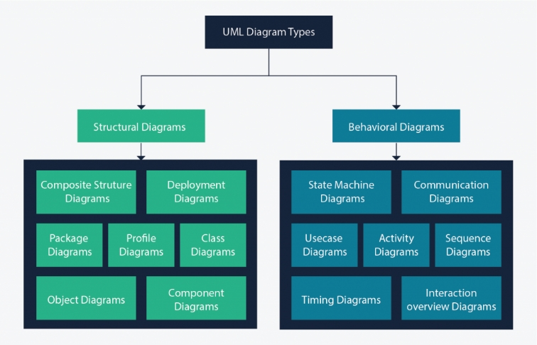

Figure 4: UML 2.5 diagrams overview (source: <https://creately.com/blog/diagrams/uml-diagram-types-examples/> )

On very important notice is that UML is not a method but a modelling language. As such to give it an approach we need to associate UML to a Unified Process (UP) in other to give our conception a methodology to follow. There exist several Unified Processes but our modelling approach will be the 2TUP (Two-track unified process) which we will use in the course of our project.

Table 10: Comparison between MERISE and UML

|  |  |
| --- | --- |
| MERISE | UML |
| It is based on procedural approach | Based on object approach |
| Suitable for relational databases design and implementation | Suitable for object-oriented design and implementation |
| It stands for Méthode d'Étude et de Réalisation Informatique pour les Systèmes d'Entreprises | Unified Modeling Language |
| MERISE is a systemic method of analysis and design of information systems. That is, it uses a systems approach. | UML is however not a method but rather an  object modeling language to which it is necessary to associate an approach to make  it a method. This is the case with the 2TUP  method: RUP and XP. |
| Merise is a method of analysis | UML is modeling language |
| Emphasizes data analysis and modelling using data flow diagrams (DFD), entity-relationship diagrams (ERD), and data dictionaries. | Emphasizes system behaviour and structure using 14 diagram types, such as use case diagrams, class diagrams, and activity diagrams |

1. STUDY OF UNIFIED PROCESSES

### **Unified Process (UP)**

A Unified Process is a generic software development method. Generic means that it is necessary to

adapt UP to the context of the project, team, domain and/or organization and also process of development of software constructed on UML; it is iterative, incremental, centered on architecture, driven by use cases and requirements.

**Iteration** is distinct sequence of activities with a basic plan and evaluation criterion that produces an internal or external output. Either the content of an iteration is improved, or users evaluate the evolution of the system.

**An increment** is the difference between two released products at the end of two iterations. Each iteration that the group is capable of integrating the technical environment in order to develop a final product and give users the possibility of having tangible results.

**Centered on architecture** the different models derived during the establishment of system must be reliable and coherent.

**Driven by use case and requirements** enables the clear definition of a user’ needs and priorities respectively thereby minimizing the risk of project failure.

The essential characteristics of the unified process are:

* It is component-based.
* It uses the UML language (set of tools and diagrams).
* It is driven by use cases.
* It is centred on architecture.
* It is iterative and incremental.

### **Two Track Unified Process (2TUP)**

2TUP is a unified process, which is built on UML and has as objective to bring solution to constraints of functional and technical changes imposed on information systems by strengthening controls on development capacities. It proposes a Y-sharped development life cycle that separates the functional aspect from the technical aspects, and the merging of these two forms the implementation aspect. 2TUP distinguishes therefore two branches: the functional and technical branches, the combination of the result of these two branches forms the third: the realization branch – where we realize our system. The diagram below illustrates the branches of 2TUP.

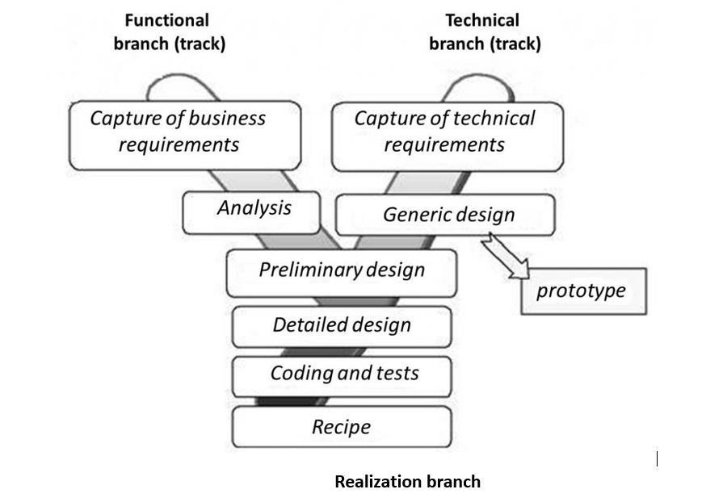

*Figure5:2TUP diagram(Source:https://www.mysciencework.com/omniscience/pervasive-mobile-healthcare-system-basedon*

*cloud-computing)*

a. The left branch (functional branch)

It captures the functional needs of a system. This ensures the production of

software that meets the needs/requirements of the user. The analysis here consists of

studying precisely the functional specification in order to obtain an idea of what the

system is going to realize, and its result does not depend on any technology.

b. The right branch (Technical branch)

The technical branch enumerates the technical needs and proposes a generic

design validated by a prototype. The technical needs include constraints and choices

related to the conception of the system, the tools and equipment as well as the

integration constraint with the existing system condition.

c. The middle branch (Realization or Implementation branch)

In this branch, we study the preliminary conception, detailed conception, and

documentation of the system. The realization branch supports the following:

**Preliminary conception:** This is the most sensitive step of 2TUP as it is the

confluence of the functional and technical branch. It is completed when the

deployment model, the operating model, the logical model, interphases and the

software configuration model are defined. We have the following diagrams:

* -Component Diagram
* Deployment Diagram
* Package Diagram
* Composite Structure Diagram

**Detailed conception:** This is the detailed design of each feature of the system. We

have the following diagrams:

* Class
* Object
* Sequence
* Timing Diagram

**Coding and testing**: This is the phase where we program the designed features and

test the coded features.

**The recipe:** Also known as the deliverables is the validation phase of the functions of

the developed system.

CHARACTERISTICS OF 2TUP

The two-track unified process was built to be used with the Unified Modeling

Language to become a method and has the following characteristics:

* **It is user oriented**: 2TUP is built from user’s expectation.
* **It is component oriented**: it offers flexibility to the model by supporting the re-use

of components.

* **It is an iterative process**: processes are being done in iterations and each iteration

shows a precise level of abstraction.

* **It is an incremental process:** allowing a better functional and technical risk management and thus constituting the deadlines and the cost control.

## **JUSTIFICATION OF THE ANALYSIS METHOD**

The reason why we chose UML modelling language and the software development process 2TUP instead of many others that exist, include:

* UML is the current standard for programming in an object-oriented language. For this reason, it is widely understood and well known making it easy for a new programmer to join the project and be productive from the very first day.
* UML diagrams allow teams to virtualize how a project is or will be working, and they can be used in any field, not just software engineering. The diagrams will allow teams to virtualize together how a system, or a process will work or did work. It can provide new ideas for how teams have to collaborate to achieve the goal of the workflow process.
* 2TUP is centered around the creation and maintenance of a model, rather than the production of mountain documents.
* 2TUP is user oriented as it permits the development of software that responds to the needs of the users through the study of the user needs.
* 2TUP is iterative and incremental, hence it enables the project team to produce refined amelioration if necessary and easily integrate it in the already existing system.
* 2TUP by permitting the project team identify and test the key functionalities of the system limits the risk related to building the system.

1. CHOICE OF THE ANALYSIS METHOD
2. JUSTIFICATION OF THE ANALYSIS METHOD
3. MODELING OF THE PROPOSED SOLUTION

PART FOUR: CONCEPTION PHASE

CONCLUSION

# FILE 3: PHASE

Preamble

Content Overview

INTRODUCTION

1. TECHNICAL BRANCH
2. Generic Design
3. IMPLEMENTATION BRANCH
4. Preliminary Design
5. Detail Conception

CONCLUSION

INTRODUCTION

1. TECHNICAL BRANCH
2. IMPLEMENTATION BRANCH
3. Preliminary Design
4. Detailed Design

CONCLUSION

PART FIVE: REALIZATION PHASE

Preamble

Content Overview

INTRODUCTION

1. PRESENTATION OF DEVELOPMENT TOOLS
2. Hardware Resources
3. Software Resources
4. TECHNOLOGY STACK

CONCLUSION

INTRODUCTION

1. PRESENTATION OF DEVELOPMENT TOOLS
2. TECHNOLOGY STACK

CONCLUSION

PART SIX: USER’S GUIDE

Preamble

Content Overview

INTRODUCTION

1. DEPLOYMENT OF THE APPLICATION
2. DESCRIPTION OF THE APPLICATION
3. Mobile Interface
4. Web Interface

CONCLUSION

INTRODUCTION

1. DEPLOYMENT OF THE APPLICATION

GENERAL CONCLUSION

PART SEVEN: ANNEX

BIBLIOGRAPHY

WEBOGRAPHY

TABLE OF CONTENTS